**SALES DATASET ANALYSIS**

CONTEXT

**OBJECTIVE**: The primary aim of this ‘Baby’ products sales dataset is to examine and assemble applicable data’s from sales dataset, understanding sales performance and strategies to deliver informative observations and uncover opportunities with data driven decisions to improve sales.

**SCOPE:** The analysis covers sales dataset focused within the,

* Time frame-Ranging between the period October 2020-November 2023.
* Product category- Baby and its relevant product types.
* Sales channel-Online sales, point of sale, draft orders, unknown .
* Key metrics-Sum of gross sales, sum of net sales, sum of adjusted sales, count of net sales.

**AUDIENCE:** This dashboard is planned for primary audience like data analyst, sales manager, marketing teams, anyone analyzing sales trends, customer patterns and optimizing pricing strategy who is in need of clear deep insights to guide their strategies and action.

ANALYSIS:

**DATA COLLECTION:** The dataset containing 28756 sales transaction information from a retail business, that indicates product information, quantity ordered, all sales related information like shipping charge, discounts, returns along with sale channel and transaction type of both ordered and return sale type.

**DATA CLEANING:** To initiate with, the dataset is formatted by freezing first row, each column is formatted accordingly by the relevant format like date column with short date, all sales column with currency. Further, the dataset is cleaned by removing duplicate entries, filling blanks with adjacent cell value, removing unwanted column. Power Query is also used to format and clean the dataset.

TECHNIQUES USED:

Dataset is analyzed using formulas, functions and other tools to create insights. Formulas and functions are used initially to separate returned order entries from normal orders to clearly analyze the sale performance and to find any outliers in net sales.

**ANALYSIS ON SALES:**

1. **ADJUSTED SALES** - Calculated by subtracting discounts, returns, shipping and taxes from gross sales.
   * **PURPOSE:** Identifies the impact on accuracy of raw sales information with all adjustments.
   * **FORMULA:** GROSS SALES-(DISCOUNTS+ RETURNS+ DISCOUNTS- SHIPPING)
2. **TOTAL REVENUE**- Represents the entire amount of money a company generates from all sales activities during a specific period.
   * **PURPOSE:** Analyze growth trends of business, indicator of company’s overall sales performance.
   * **FORMULA:** SUM('ANALYSING DATA ADJUSTED DATA'!L2:L28269)
3. **AVERAGE ORDER VALUE -** Tracks the average dollar amount spent each time a customer places an order on website.
   * **PURPOSE:** Understand customer buying behavior revealing money spend per purchase.
   * **FORMULA:** AVERAGE('ANALYSING DATA ADJUSTED DATA'!U2:U28269)
4. **TOTAL DISCOUNTS -** Indicates total reduction in the price of a product from its actual price based on criteria.
   * **PURPOSE**: Quantifies the overall impact of discounting practices on sales revenue and profitability.
   * **FORMULA**: SUM('ANALYSING DATA ADJUSTED DATA'!M2:M28269)
5. **SEGMENTING -** Segmenting data based on sale type, sales channel, products calculating sum of adjusted sales, average adjusted sales, sum of returns, count of orders.

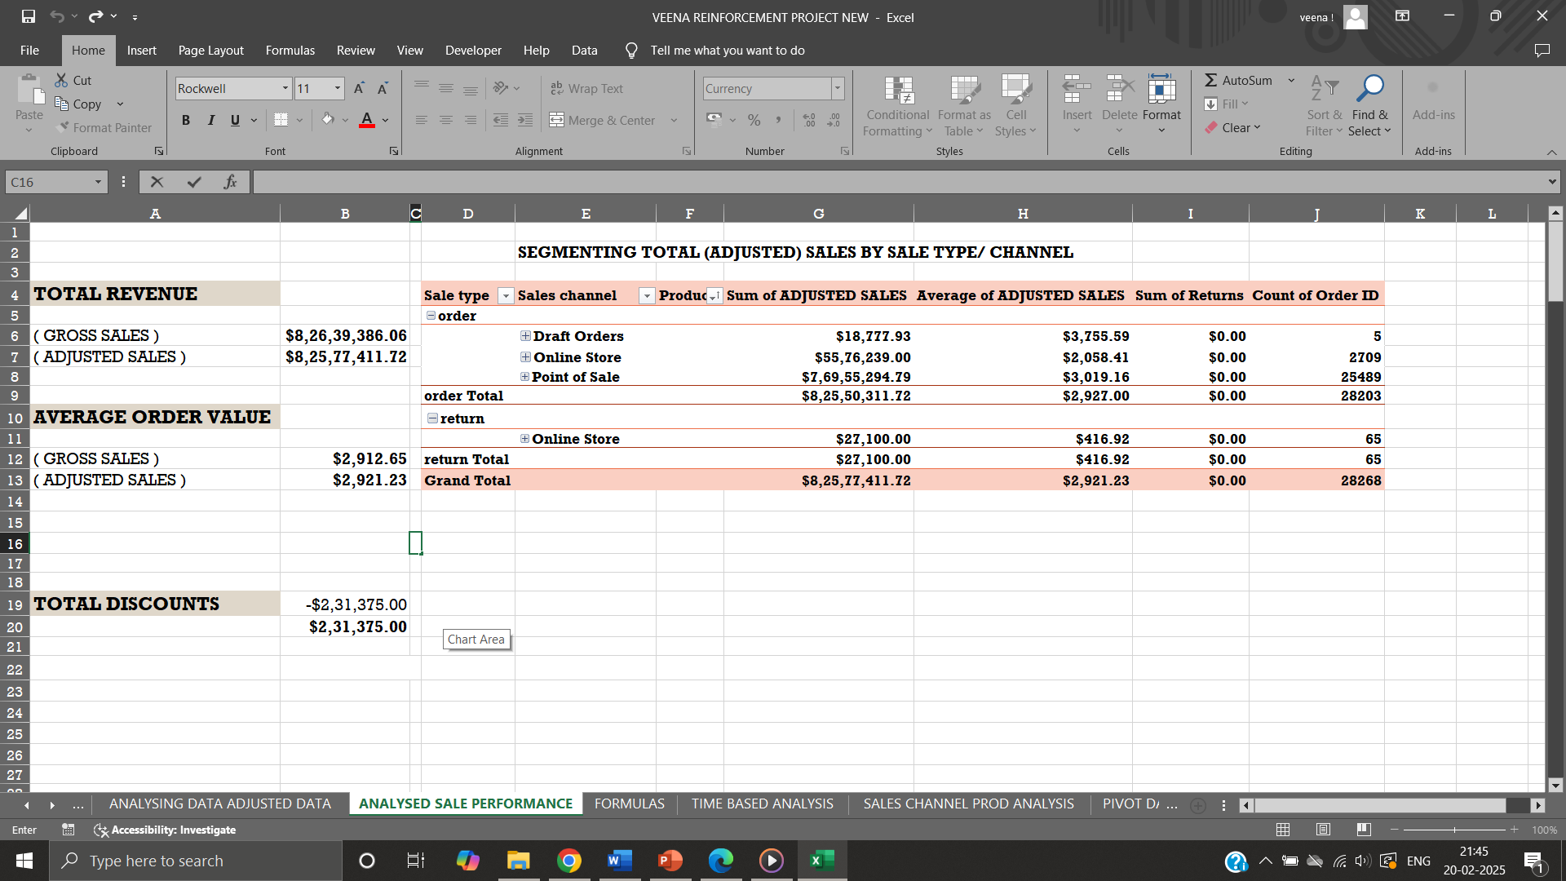

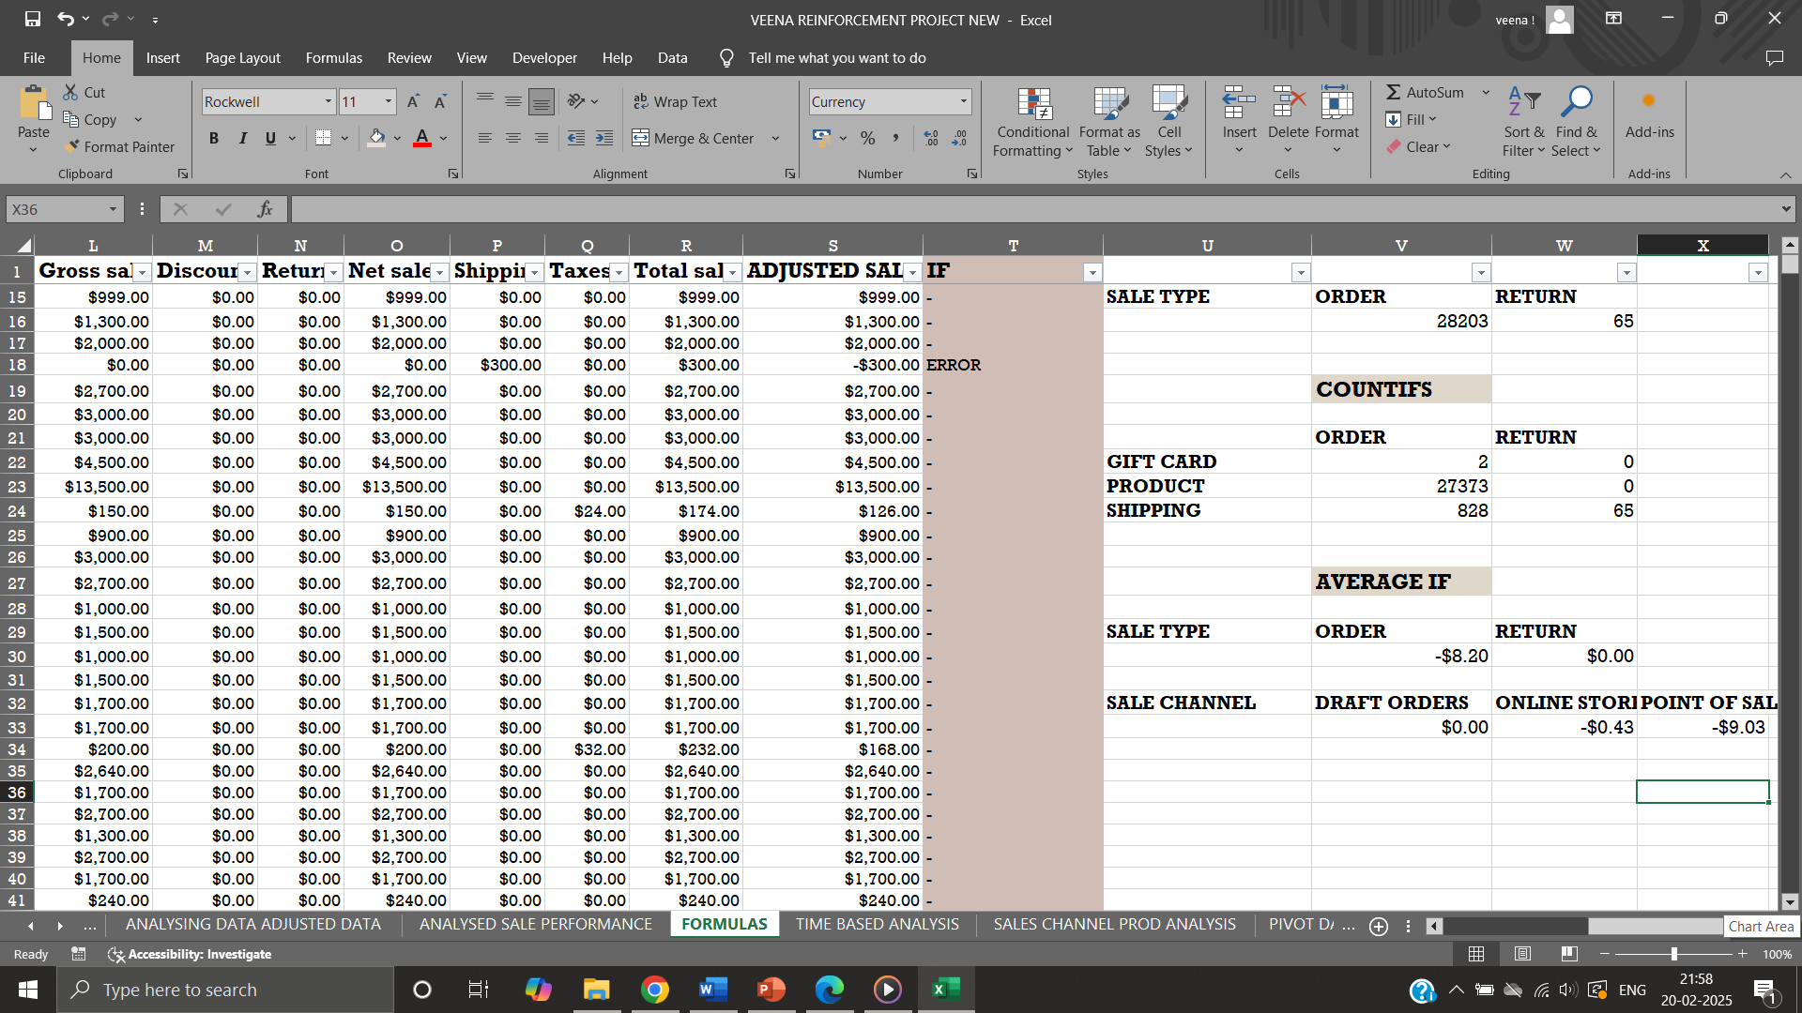

**TIME BASED ANALYSIS:**

A statistical method called time series analysis, examining data’s collected over a period of time to identify patterns, trends, essentially looking for changes in value over time and factors influencing the change.

Sales increases each year reaching maximum in the year 2023 second quarter, with a maximum sales on 20 May 2023 of about $43,70,112.00.

Date functions are used to categorize and analyze sale performance over time.

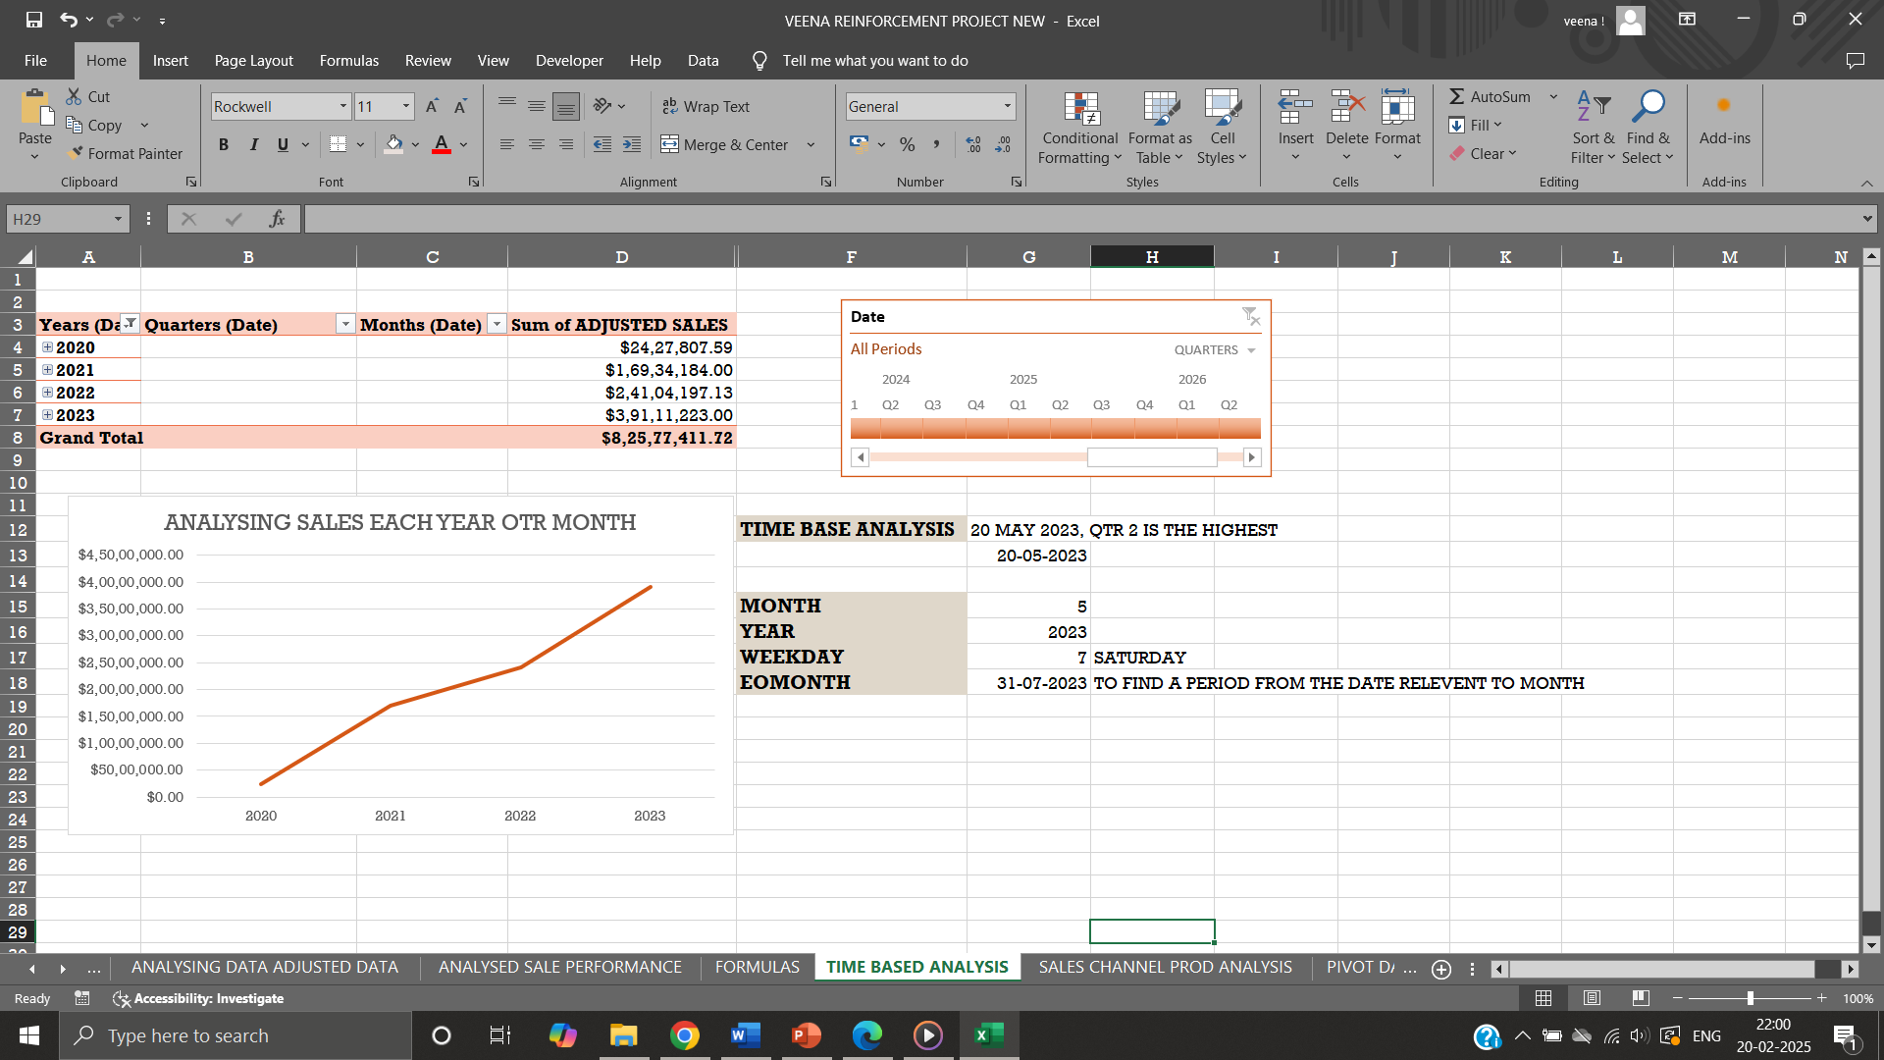

**SALES CHANNEL AND PRODUCT TYPE ANALYSIS:**

* Total sales, average sales and total returns for sales channel and product type is analyzed using pivot table with respect to products.
* Product type baby formula generated highest revenue of $4,19,38,837.44, average sales of $4,569.50 with a net quantity of 9178.
* Baby Activity Toys & Games & Gifts Generated the lowest sales of $900.00.
* Point of sale- sale type is the preferred medium to purchase baby products.
* Frequently purchased product ‘APTAMIL BABY MILK 800 GM’ under baby formula product type.

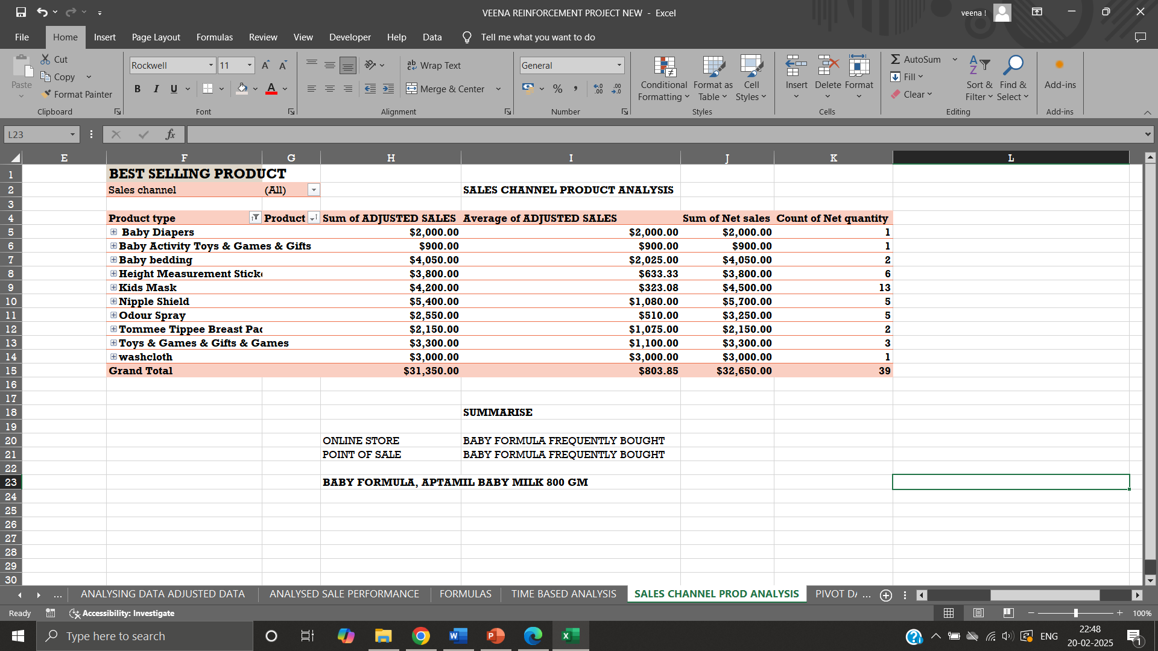

**RETURN ANALYSIS:**

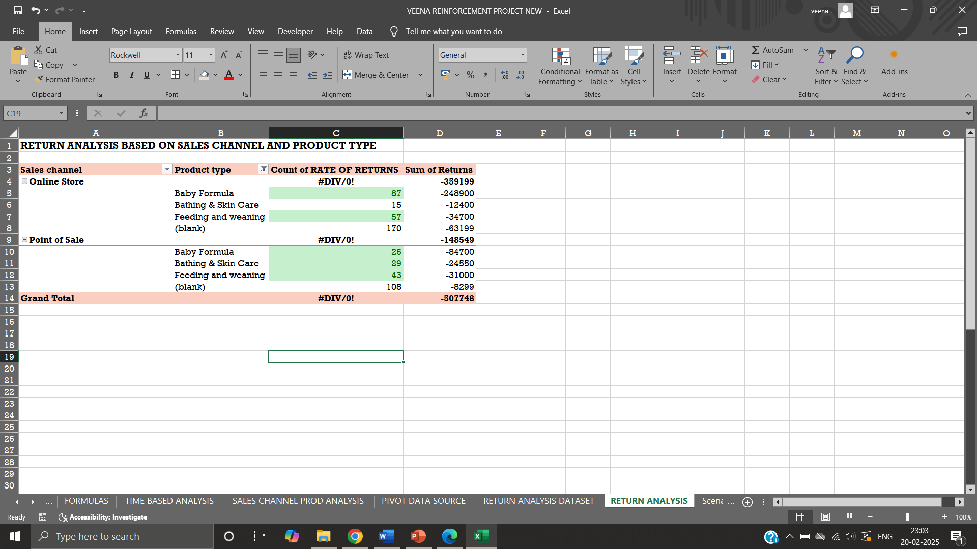

* The process of examining and interpreting data about the returns generated by a business, typically to access profitability, understand the level of risk associated with receiving returns.
* Feeding and wearing product type has maximum returns in both the sales channel- point of sale and online sales.
* **FORMULA**: Rate of Return = (returns/gross sales)*100

**WHAT IF ANALYSIS:**

* Tool used to analyze and understand impact of change in cell values to know how that change impacts the outcome of formula.
* **GOAL SEEK** - A what-if analysis tool used to find input value required to achieve a desired result, trial and error method.
* For a net sales of $10,00,000.00 with formula, price being $2,125.89 the quantity required to achieve target is obtained as 470.4 units using goal seek.

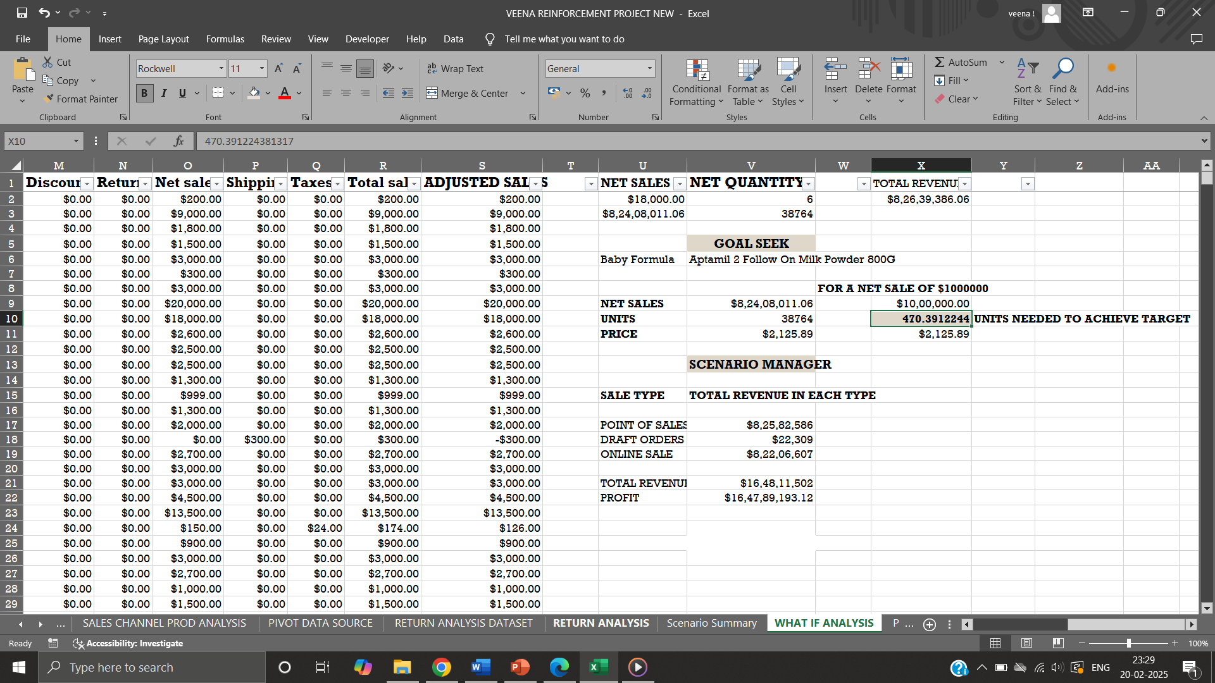

* Senario manager a whatif analysis tool helps to create and compare different data scenarios. Different sales type-total sales comparision for 10% increase and 5% decrease in value

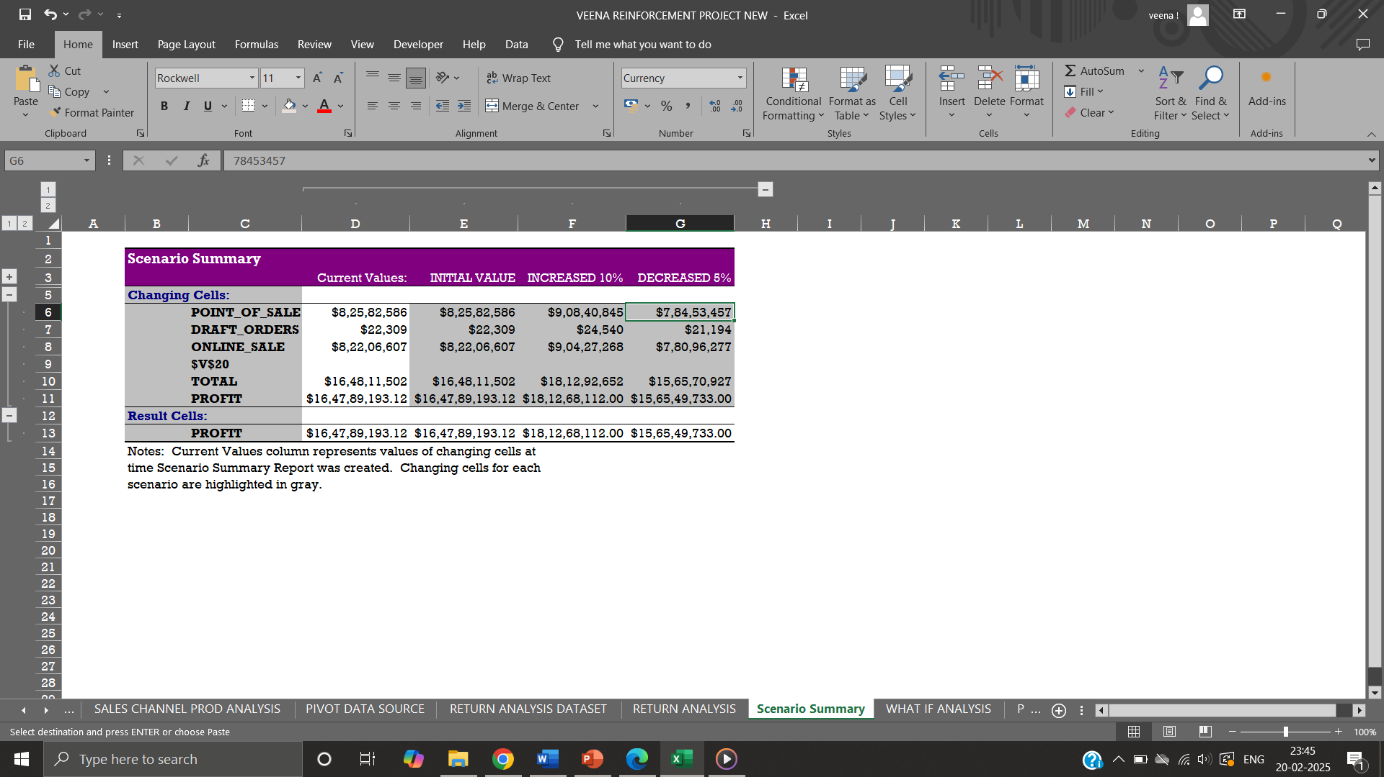

**PIVOT TABLE AND CHARTS:**

* Pivot tables in excel used to summarize large dataset in simple tabular form making analysis easier to access, explore and present data. Pictorial representation of pivot table is pivot chart.
* Sales performance with respect to any category can be easily compared and analyzed precisely.

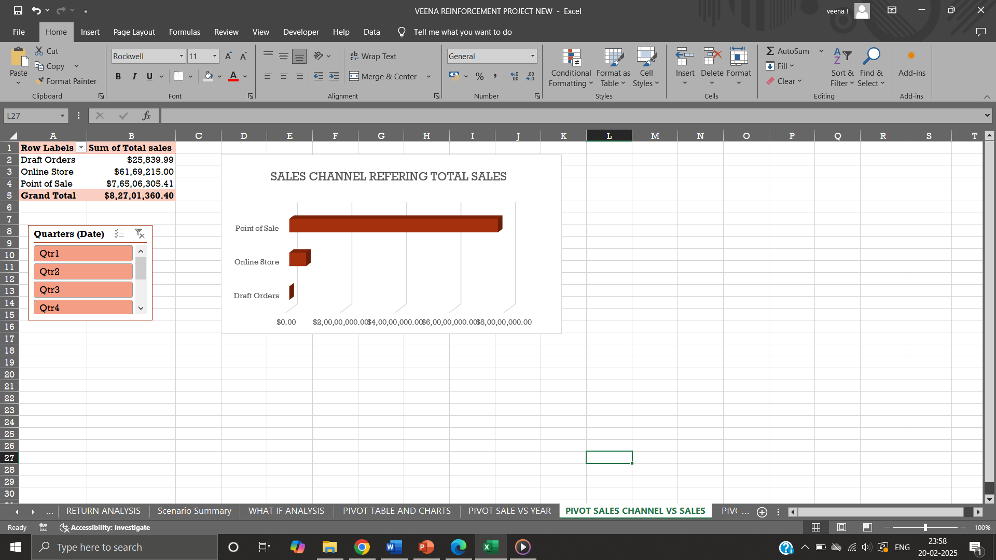

**DASHBOARD:**

A Dashboard is used to monitor, organise, analyse and update large dataset in real-time, by using visual filtering tools like slicers and KPI’s that makes it more interactive.

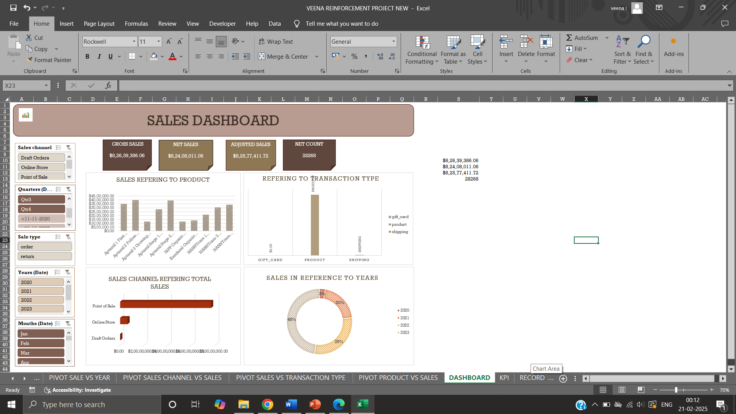

**KPI’s:**

1. **SUM OF GROSS SALES- $8,26,39,386.06**

* Gross revenue is the total amount of money a business makes from selling its products before any deductions. sum of gross sales is the sum of entire gross sale value.

1. **SUM OF NET SALES- $8,24,08,011.06**

* Net sales is the total amount of money a business earns from sales subtracting gross sales from returns and discounts. Sum of net sales is the total net sales obtained.

1. **SUM OF ADJUSTED SALES - $8,25,77,411.72**

* refers to the total calculated value added up all the sales figure after any necessary adjustments are made. Sum of adjusted sales is the total adjusted sales value.

1. **COUNT OF NET SALES - 28268**

* total sales count is measured, total number of sales entries corresponding to unique sale ID gives count of net sales for each product type.

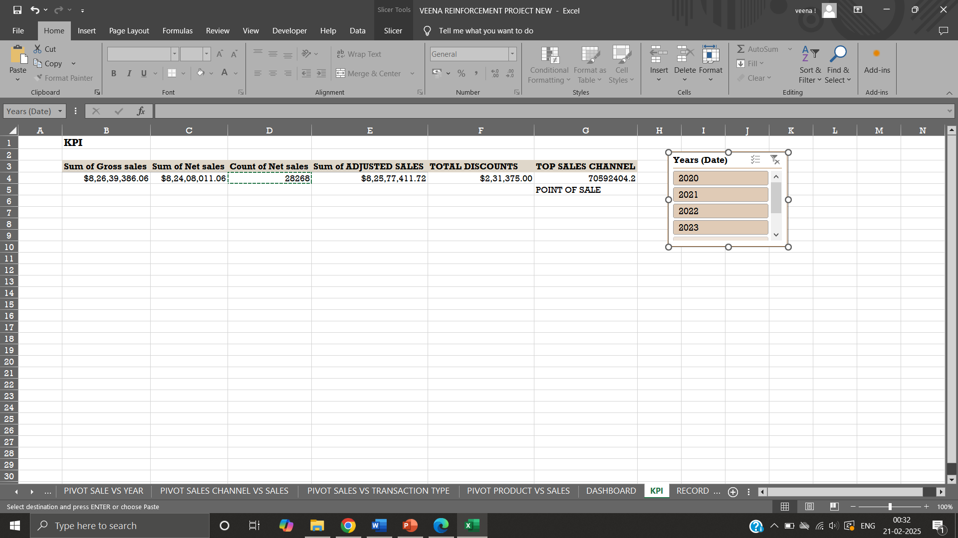

**MACROS:**

* Same set of actions that can be recorded and run automatically across different sheets to perform repetitive tasks .
* Formatting columns, freezing rows, bolding headers, similar analysis are made across different sheets using macros assigning it buttons and accessing to do task

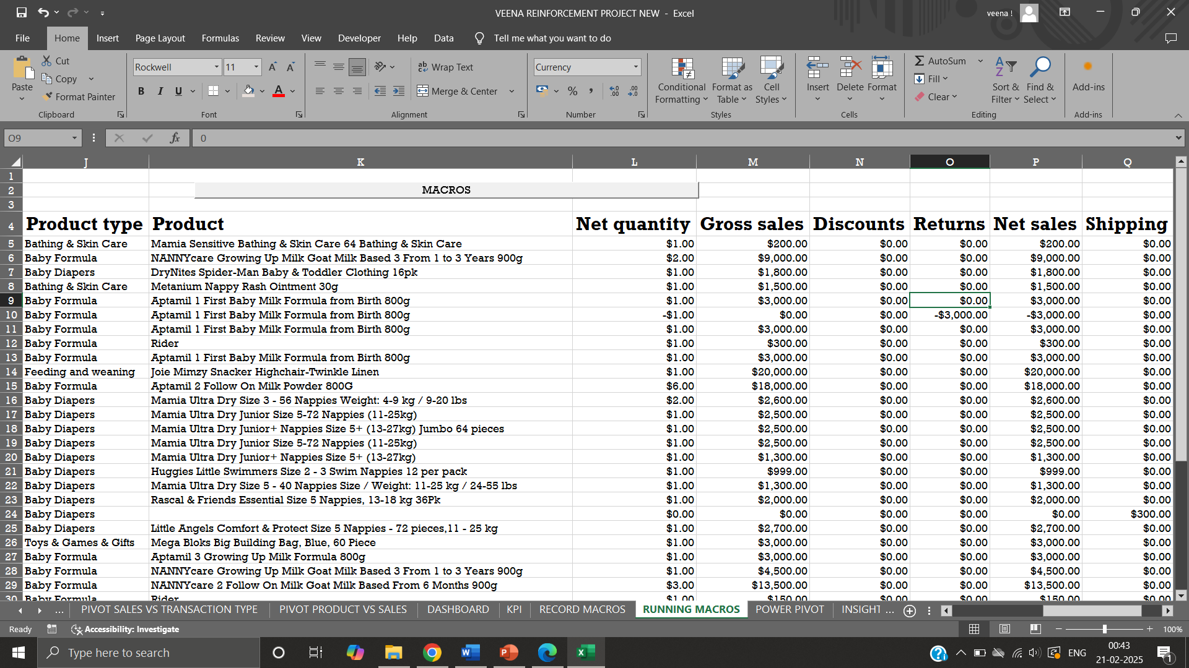

**POWER PIVOT:**

* Power pivot is an excel add-in used to perform powerful data analysis and create sophisticated data models. Mashing up of large volumes of data from various sources perform information analysis rapidly and share insights.

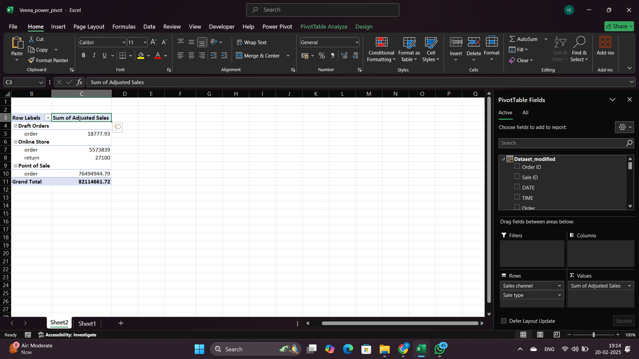 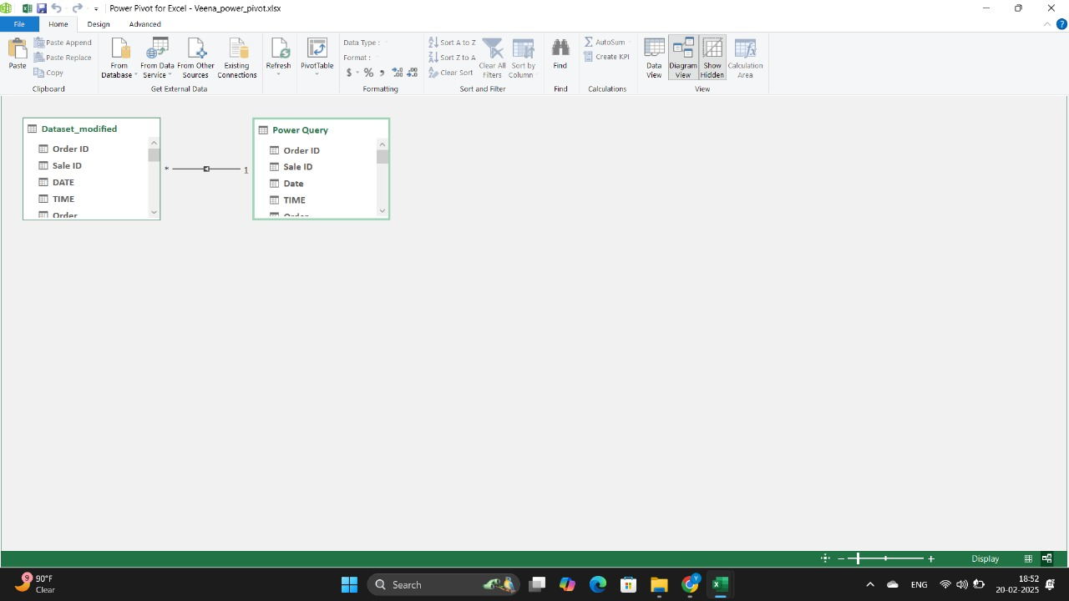

FINDINGS

* **TOTAL SALES PERFORMANCE**- During this period October 2020- November 2023, sales performance gradually increased and peaked at second quadrant in the month May of the year 2023.
* **CATEGORY ANALYSIS**- Aptamil Stage2 follow on milk powder 800gm has total revenue of $39,19,900.00 with count of 740 units ordered. Baby Activity Toys & games & gifts - color wonder paw patrol has generated low sales of $950.00 with only 2 units sold. Aptamil organic baby rice 100gm 4th+ generated negative revenue in online sale channel by -$300.
* **SALES TRENDS-**Sales increased in the year 2023, second quarter respectively. Highest revenue is created in Point of Sale channel type.

CONCLUSION

Sales dataset is analyzed and an interactive dashboard is created for better understanding of performance, impacts of strategies and implementing future recommendations will improve overall sales.

**KEY TAKEAWYS**

* From the dataset product baby formula experienced significant overall growth in sales in product type Aptamil Stage2 follow on milk powder 800gm-$39,19,900.00 - count of 740 units.
* Seasonal trends indicate a need for promotional strategies during slower months to maintain sales momentum.
* Price and quality of products are considered as two important factors that moderately influence consumers.

RECOMENDATIN

* Proposing directions to enhance its sales with price elasticity.
* Promotional activity, better marketing.
* Product launches considering safety, cleanliness and sensitive baby products.
* Potential areas like Regional analysis should be considered.
* Increasing quality bases on addressing wellness, sustainability and environmental issues.

**FUTURE CONSIDERATIONS:**

* Conduct customer surveys to gather feedback on product offerings and service experience.
* Explore expanding product type to capitalize on existing demand.
* Monitor competitor activities to identify potential threats in the market.
* Conduct in depth geographical understanding of sales.
* Future studies to examine consumers buying behavior and identify the factors that influence buying decisions in purchasing baby care products.

**THANK YOU**

REPORTED BY,

VEENA SRI PM,

DATA ANALYTICS AND DATA SCIENCE,

RP-33.